# PRE-LAB QUESTIONS

1. Identify minutiae A - C in the figure below..

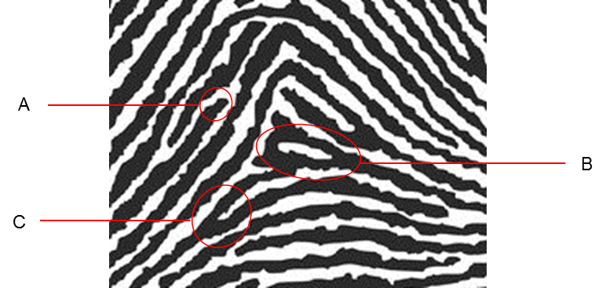

**Minutiae to be identified for Pre-Lab Question 1.**

1. You are a CSI and suspect there are fingerprints on a dark blue car door. What color fingerprint powder would you use to dust for prints? What color would you use if the car door was white? Explain your reasoning.